Basic navigation and symbols cheat sheet 🡪 

Controlling CO cheat sheet 🡪 

Finance FI cheat sheet 🡪 

Fiori cheat sheet 🡪 

ABAP cheat sheet 🡪 

SD cheat sheet 🡪 

MM cheat sheet 🡪 

* More information about Hana in-memory OLAP/OLTP by Hasso Plattner 🡪 <http://s-prs.co/v485708>

**t-codes used in ECC which are deprecated in S/4 Hana**

t-code SE16 table PRGN\_CORR2 – on the left deprecated.

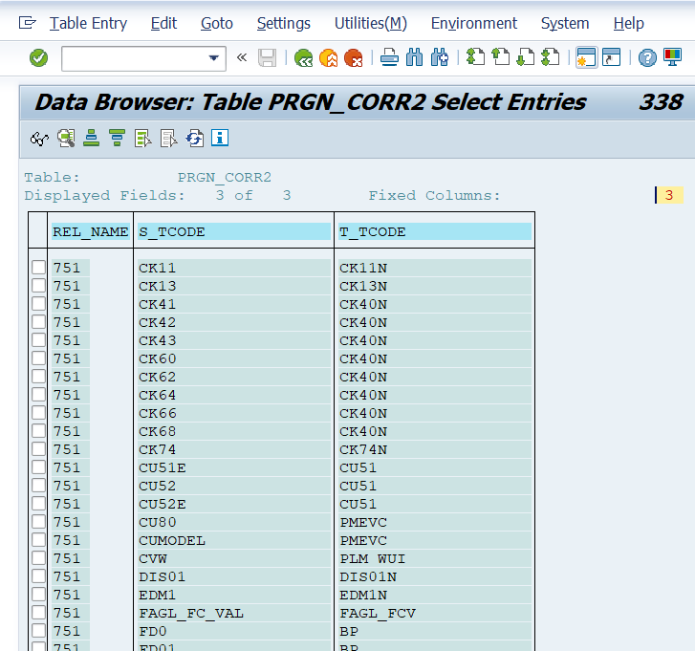

Parameters to use in t-code SU3

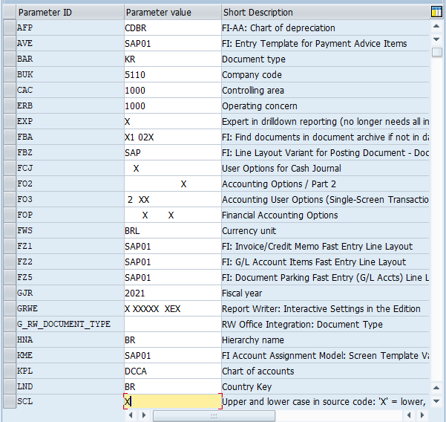

Fiori Apps List

[SAP Fiori List](https://fioriappslibrary.hana.ondemand.com/sap/fix/externalViewer/)

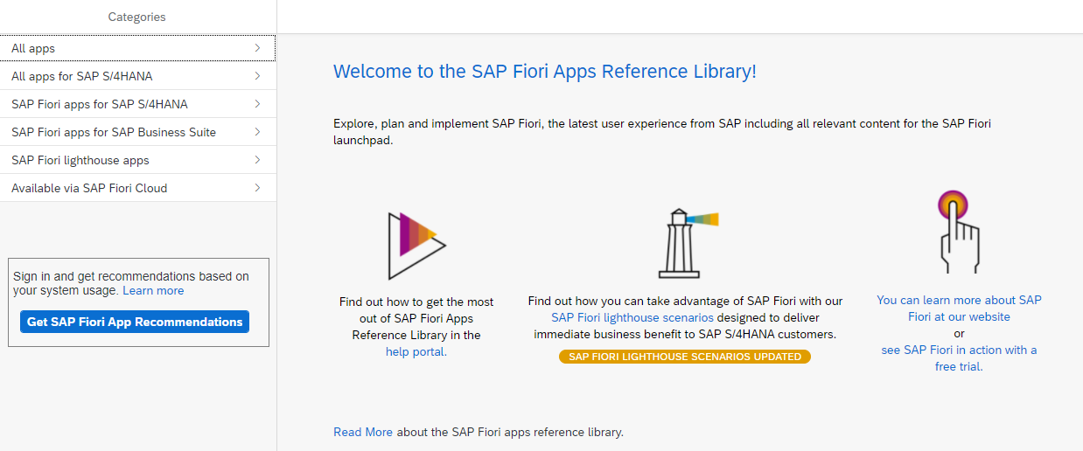

**Activities IMG – Transactions Configuration Tree**

ORFA – Asset Accounting

FAGL\_FLEXGL\_IMG – Financial Accounting

GLFLEXIMG – New GL

FOAR00 – Task Menu

SUIM – User Information System

* Go to table TSTC and on field Program = \*IMG\* for consultants
* Go to table TSTC and on field Program = \*menu\* for users
* Another way is table TSTCT (transactions text) and table TSTCP (transactions parameters) where can be search by t-code SM30 or by table.
* To create your own Menu Are go to t-code SE43 – Search for \*00\* \*MN\* for more t-codes

**User Menus**

SAP1 – All reports - disseminate

ASMN – Asset Accounting

FIAA – Asset Accounting Information

FDMN – Customer Accounting

FKMN – Vendors Accounting

F000 –Financial Accounting ]

ORK0 – General Controlling

ORKL – Cost and Revenue Element Accounting Controlling

FGM0 – Special Purpose Ledger

CKML – Actual Costing / Material Ledger

FGRW – Report Writer

SISU – Industrial Solution – Utilities

PC37 – Payroll Brazil

Questions for a new SAP project or enhancement

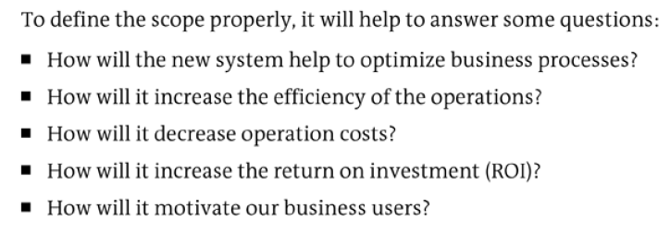

Pros and Cons – Project S/4Hana

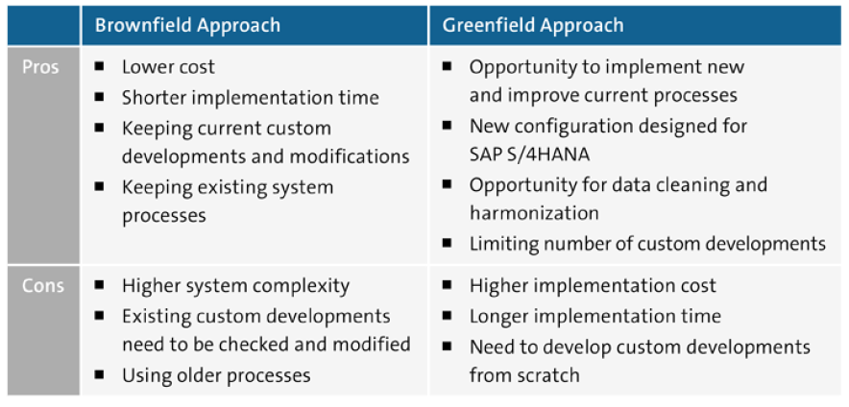

Table ACDOCA

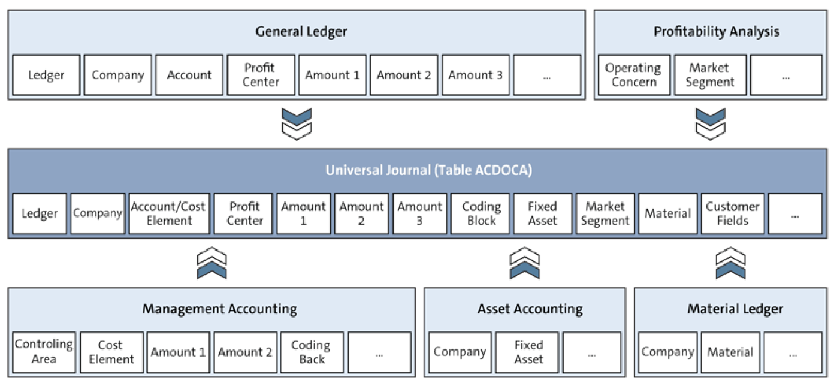

Obsolete tables – exist in S/4Hana only for compatibility reasons as CDS views (core data services)

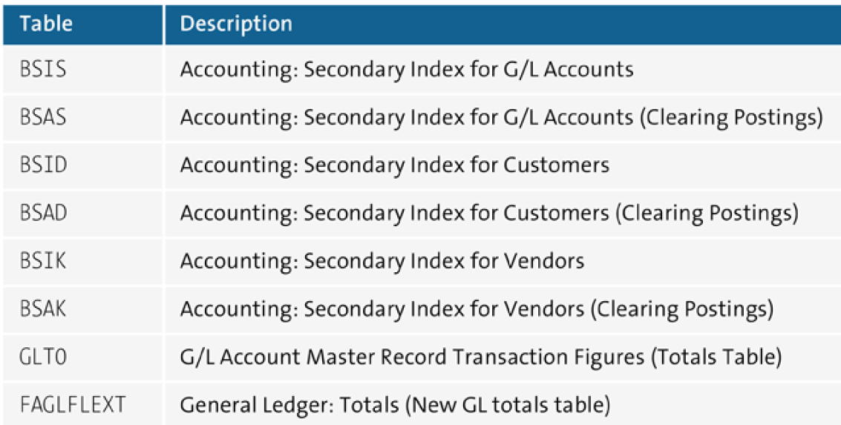

Company Codes for my study – client 400 – best practices

2520 – Canada Company

2530 – USA Company

2540 – Brazil Company

I have problems when creating CC 2520 and SAP Help recommended me t-code FINS\_CUST\_CONS\_CHK and FINS\_CUST\_CONS\_CHK\_P to check consistency in company codes.

**Manual insert in table**

To verify if there is any manual addition to a table run report RKSE16N\_CD\_DISPLAY on t-code SE38 for changes in a table.

Note report RKSE16N\_CD\_SHOW\_DELETE (0bsolete on Hana check SAP Note 1360465)

Transaction SEARCH\_SAP\_MENU

T-code that helps to find other transactions, just the transaction, enter the word and SAP will bring every transaction with that name.

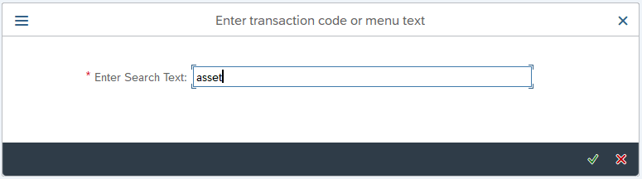

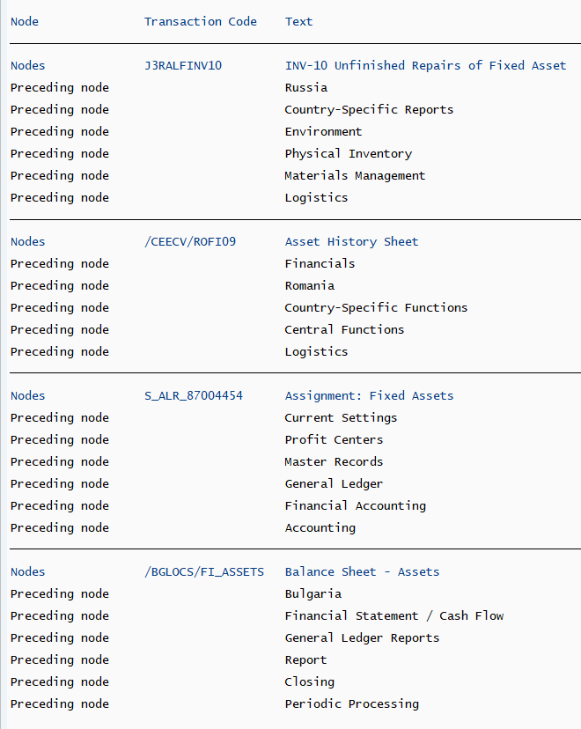

SAP on azure – Study

<https://blogs.sap.com/2021/02/06/get-certified-microsoft-certified-azure-for-sap-workloads-specialy/>

<https://docs.microsoft.com/en-us/learn/certifications/azure-for-sap-workloads-specialty/>

<https://github.com/Azure/sap-hana>

### SAP Notes

The SAP Workloads documentation from Microsoft references several SAP support notes, some of which you might want to read carefully and bookmark.

* [1928533 – SAP Applications on Azure: Supported Products and Azure VM types](https://launchpad.support.sap.com/#/notes/1928533)
* [2015553 – SAP on Microsoft Azure: Support prerequisites](https://launchpad.support.sap.com/#/notes/2015553)
* [2513384 – SUSE Linux Enterprise Server for SAP Applications on Azure](https://launchpad.support.sap.com/#/notes/2513384)
* [2694118 – Red Hat Enterprise Linux HA Add-On on Azure](https://launchpad.support.sap.com/#/notes/2694118)
* [1409604 – Virtualization on Windows: Enhanced monitoring](https://launchpad.support.sap.com/#/notes/1409604)

Books so far

* [SAP on Microsoft Azure Architecture and Administration](https://www.sap-press.com/sap-on-microsoft-azure_5174/) by [Ravi Kashyap](https://linkedin.kashyap.one/) [SAP PRESS]
* [SAP on Azure Implementation Guide](https://www.packtpub.com/product/sap-on-azure-implementation-guide/9781838983987) by [Bartosz Jarkowski](https://people.sap.com/bartosz.jarkowski4" \t "_blank) and Nick Morgan [Packt]

OpenText VIM – Vendor Invoice Management

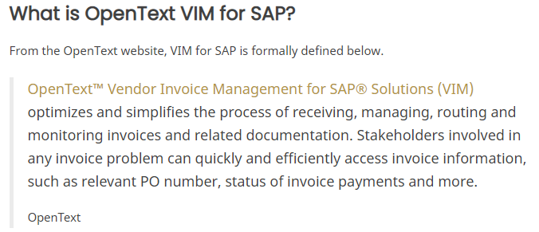

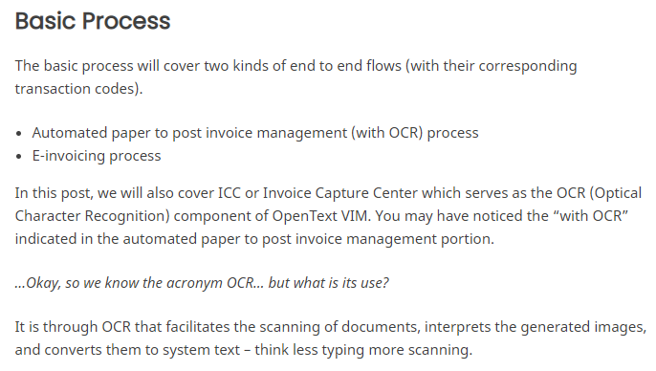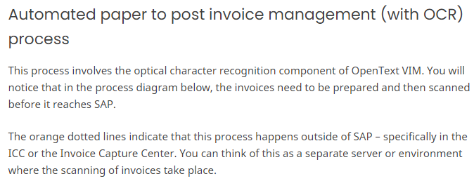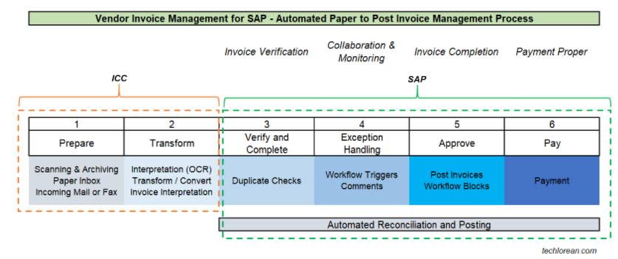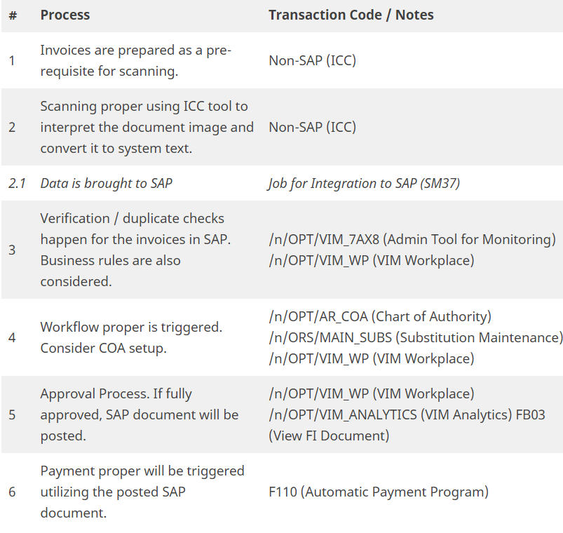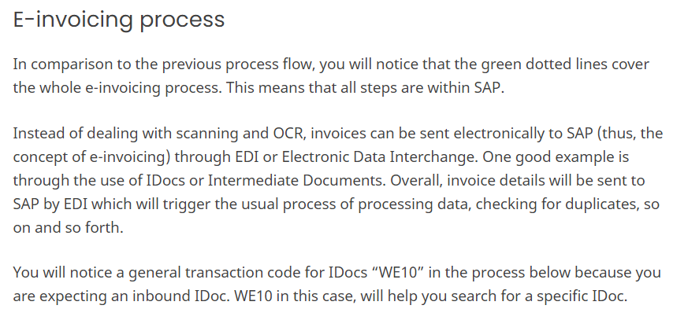

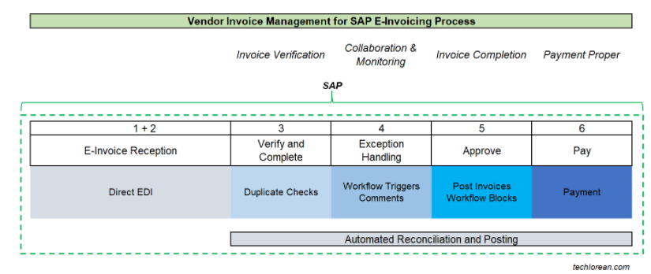

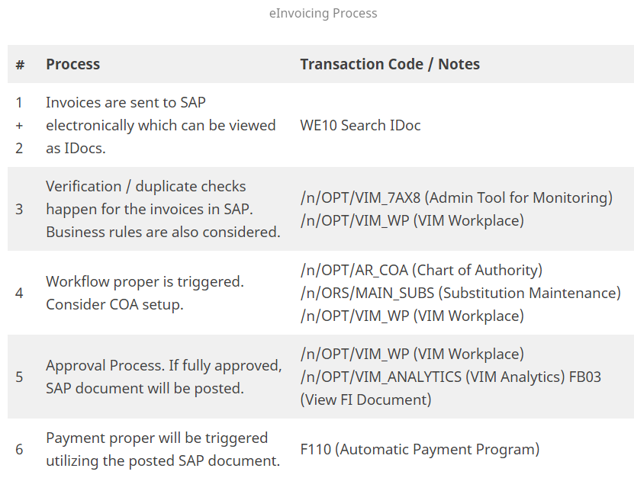

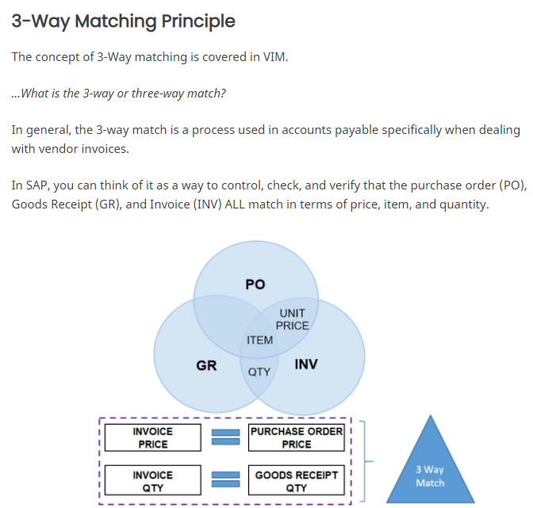

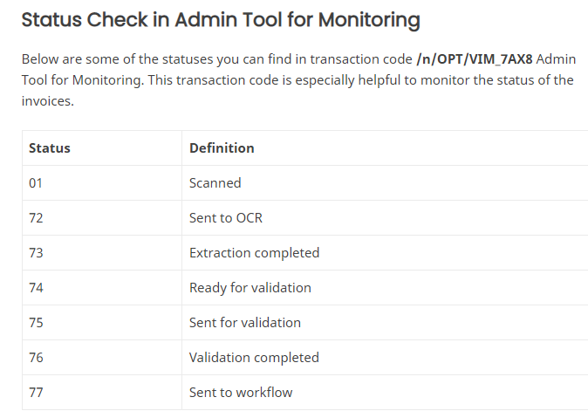

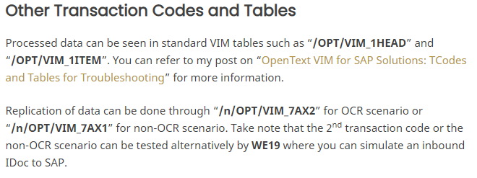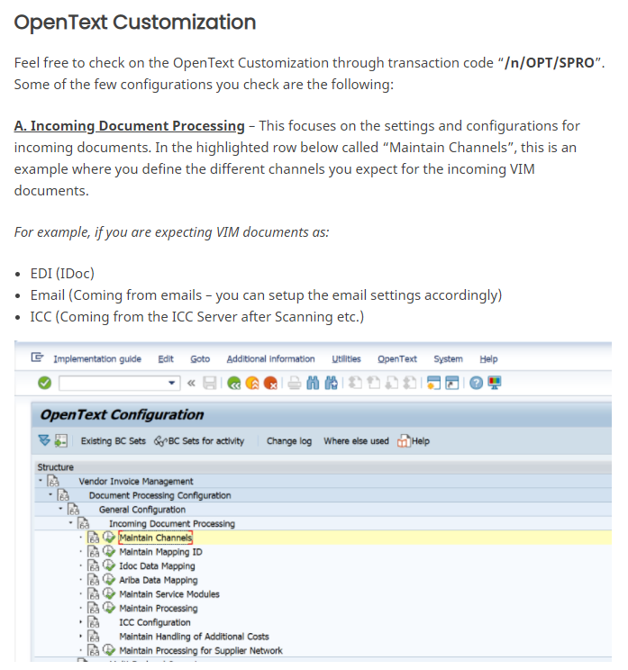

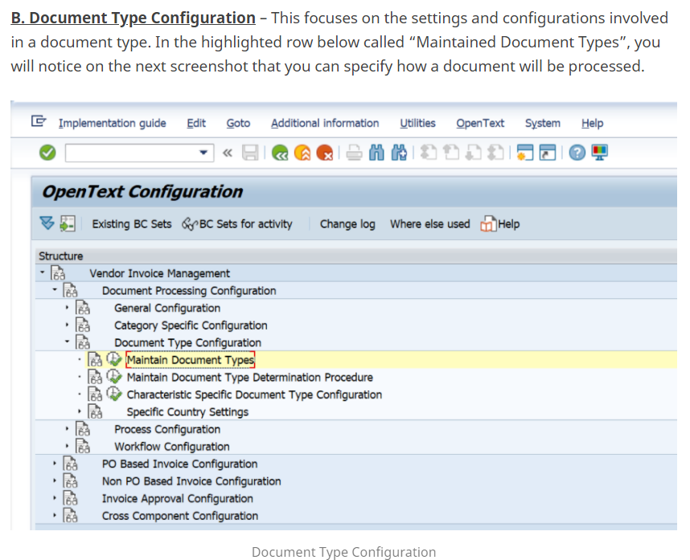

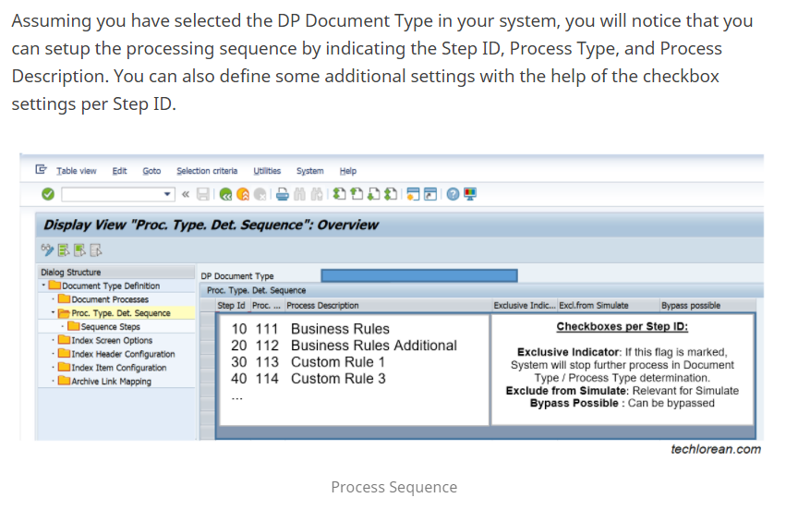

OPENTEXT VIM FOR SAP SOLUTIONS: TCODES AND TABLES FOR TROUBLESHOOTING

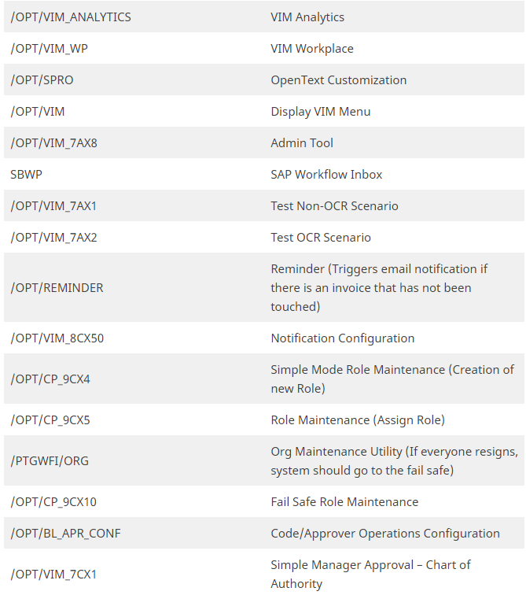

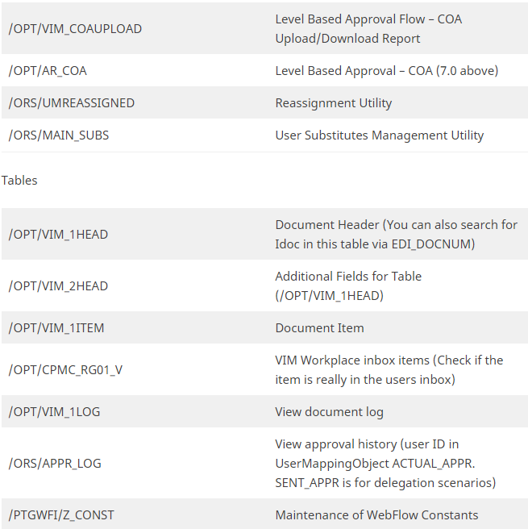

MM Steps

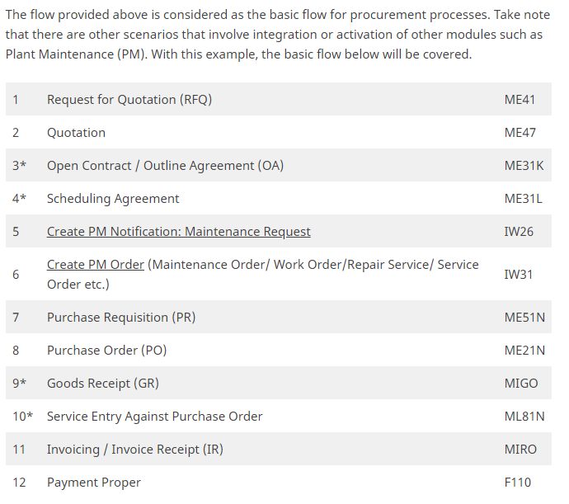

Resourceful websites

[Techlorean. – Life in Tech. SAP Consultant.](https://techlorean.com/) – Many basic courses with good contente

ABAP Cheat Sheet – IDOC &

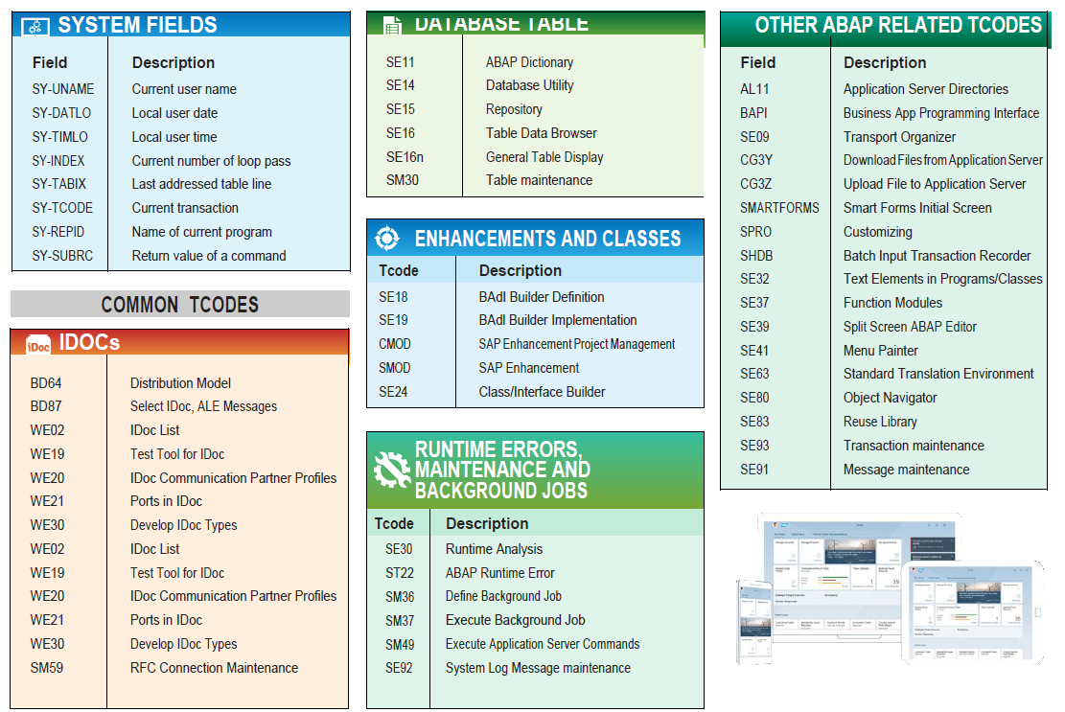

**Payments for Brazil**

Payments to Brazil for bar code and without bar code using Febraban CNAB 240, segments N and O starting from version 2020 on premise and cloud 2005

<https://blogs.sap.com/2020/08/31/utilities-and-tax-payments-in-brazil/>

**Fields by Country**

In the transaction OY17 is possible to check the length of many fields and all of them are related to localization.

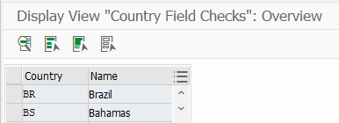

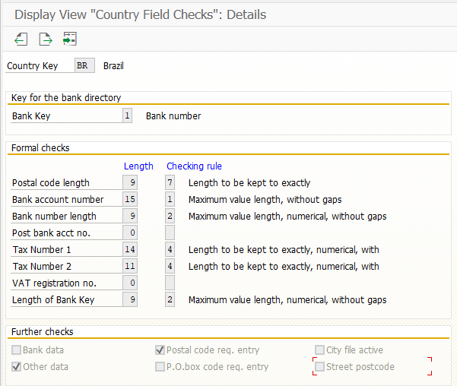

**HELP SAP – See FI**

Brazilian localization only – very good for AP and AR payments

<https://help.sap.com/saphelp_globext607_10/helpdata/en/97/dd032e5c08f74a8f45bce8c0f7ceb3/frameset.htm>

**SAPUI5 for Beginners**

<https://blogs.sap.com/2020/12/15/learning-sapui5-for-beginners/>

**Finance Tutorials by SAP**

[Task Tutorials (ondemand.com)](https://education.hana.ondemand.com/education/pub/s4/index.html?library=library.txt&show=group!GR_B06D29AAEF1CFBC#group!GR_38306E84FD587881) – with vídeos and manuals.

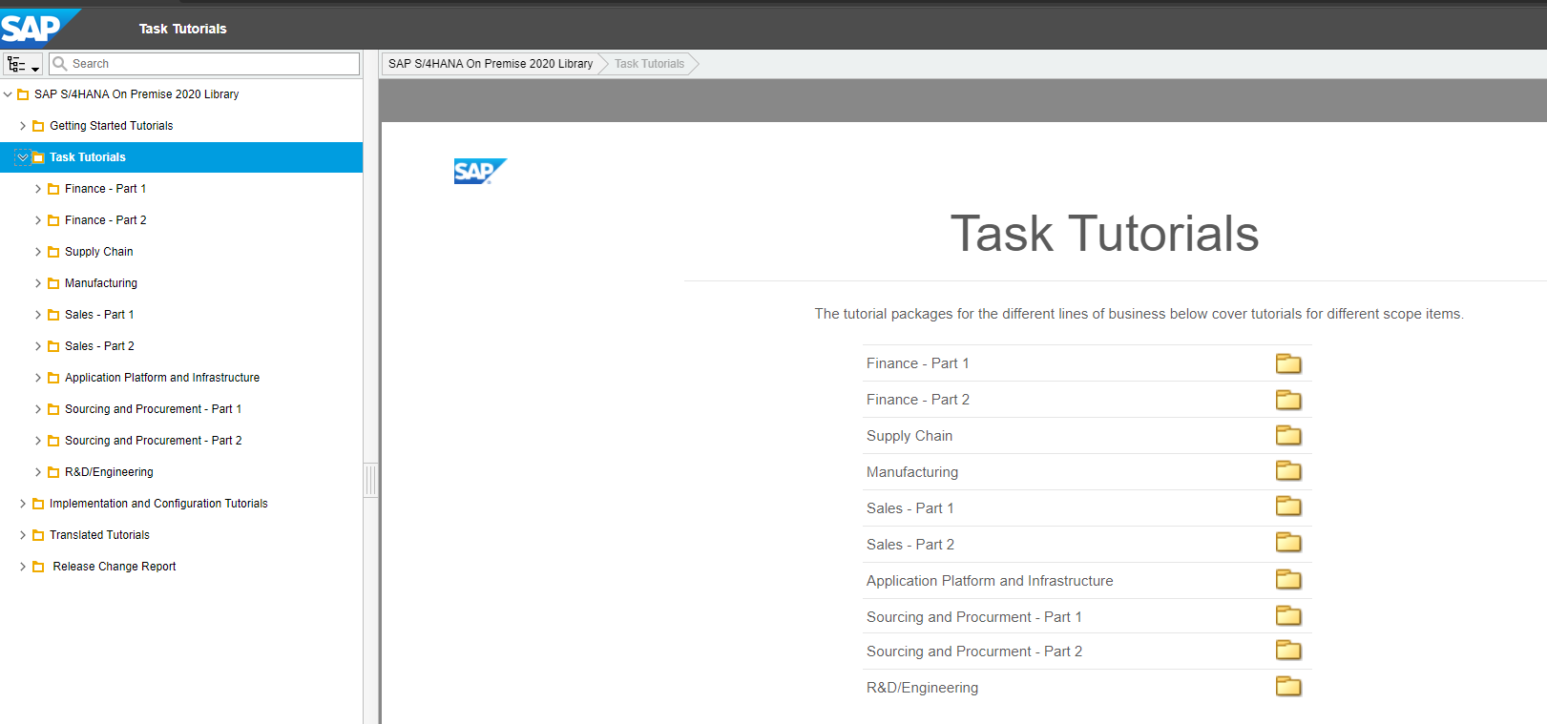

**Record to Report – Blogs from SAP**

[R2R Series Blog #1: Record to Report Blog Series Kick Off | SAP Blogs](https://blogs.sap.com/2021/08/04/record-to-report-blog-series-kick-off/)

Good financial subjects to study.

